Demo Scenarios for Pub/Sub Middleware
The final objective of developing middleware is to assist application development. Therefore, we develop a sample application for traffic management based on our middleware.
Application Interface
The application should provide interfaces which can be easily used to define events. The interface looks as follows.
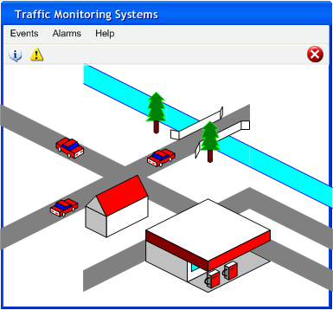
Scenario 1: Traffic Jam Event
Attributes: area, no. of vehicles, average speed.

Scenario 2: Potential Collision Event
Attributes:

Scenario 3:

